Build a Vulnerable REST API and Conduct Penetration Testing on It
Project submitted for the partial fulfillment of the requirements for the course.
Department Computer Science and Engineering
School of Engineering and Sciences

Under the Guidance of
Dr. Bhaskara Santosh Egala

Submitted by
Raya Srujana Reddy
AP22110011502
CSE-Y

SRM University–AP
Neerukonda, Mangalagiri, Guntur
Andhra Pradesh – 522 240
[April , 2025]

Table of Contents:
- Abstract
- Problem Statement
- Project Overview
- Tools and Technologies Used
- List of Vulnerabilities
- API Source Code (Vulnerable)
- JSON Test Payloads
- POST Usage Instructions
- Penetration Testing Results
- Specific Vulnerability Focus: Command Injection
- Fixed Code for Command Injection
- Conclusion

Abstract:

This project aims to simulate a realistic REST API with multiple common web security vulnerabilities. It allows security researchers and learners to understand, test, and mitigate real-world attack scenarios such as SQL Injection, XSS, IDOR, and Command Injection. A specific vulnerability (Command Injection) was also mitigated with secure coding practices.

Problem Statement:
Web applications often face security threats due to insecure coding practices. Understanding these vulnerabilities hands-on is essential to learning how to identify and prevent them. This project was developed to demonstrate vulnerabilities in a controlled environment and perform penetration testing to validate them.

Project Overview:
- The application is a Flask-based REST API exposing endpoints vulnerable to multiple security flaws. A single endpoint /test_all_vulnerabilities tests several vulnerabilities using a crafted JSON request.
- A separate /execute endpoint is used to demonstrate and fix command injection.

Tools and Technologies Used:
- Python 3
- Flask Framework
- SQLite3 Database
- Postman / Curl for API testing
- Linux / Windows OS
- OWASP Testing Guide (for methodology)

List of Vulnerabilities:

- SQL Injection
- Plaintext Password Storage
- Cross-Site Scripting (XSS)
- Weak Authentication
- Predictable Token
- Brute Force (No Rate Limiting)
- Insecure Direct Object Reference (IDOR)
- Command Injection (eval)

API Source Code (Vulnerable):

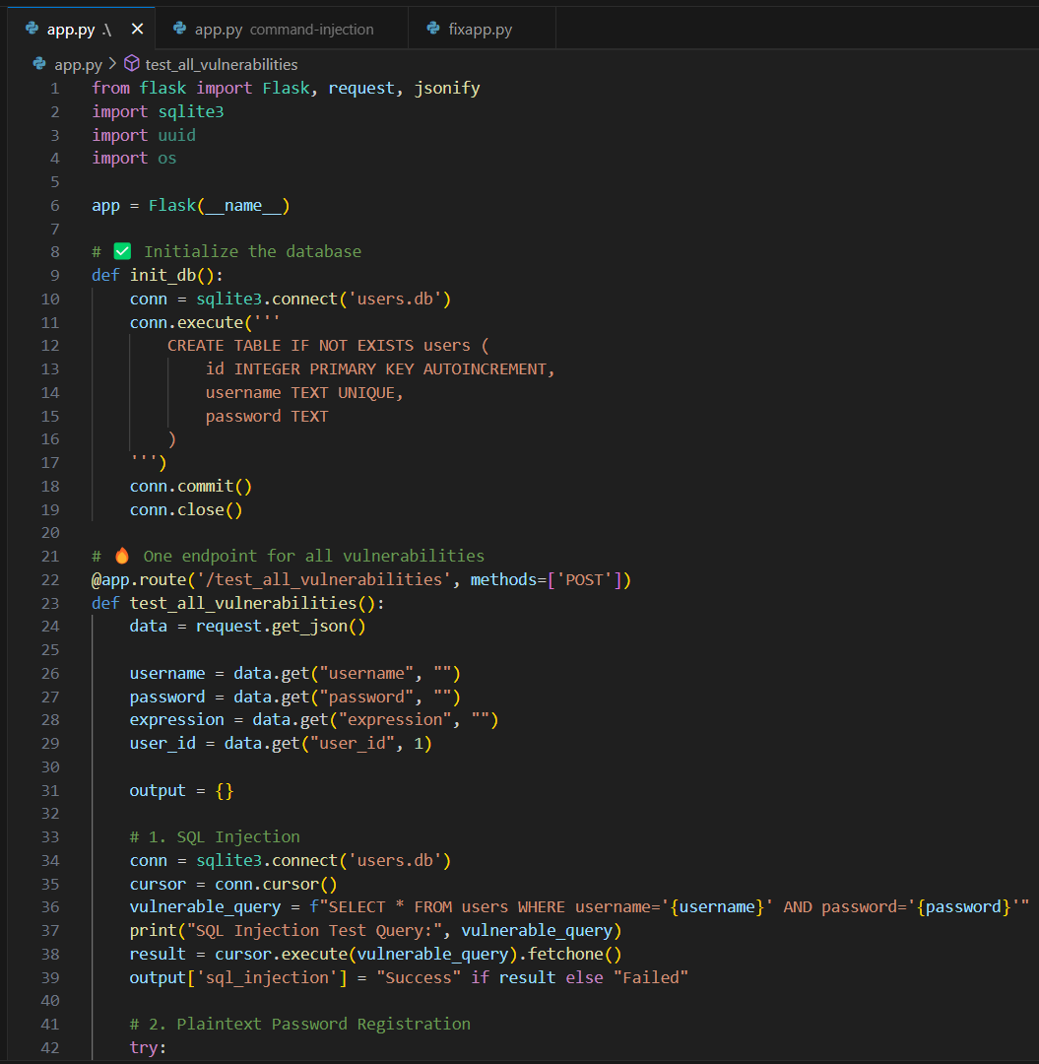
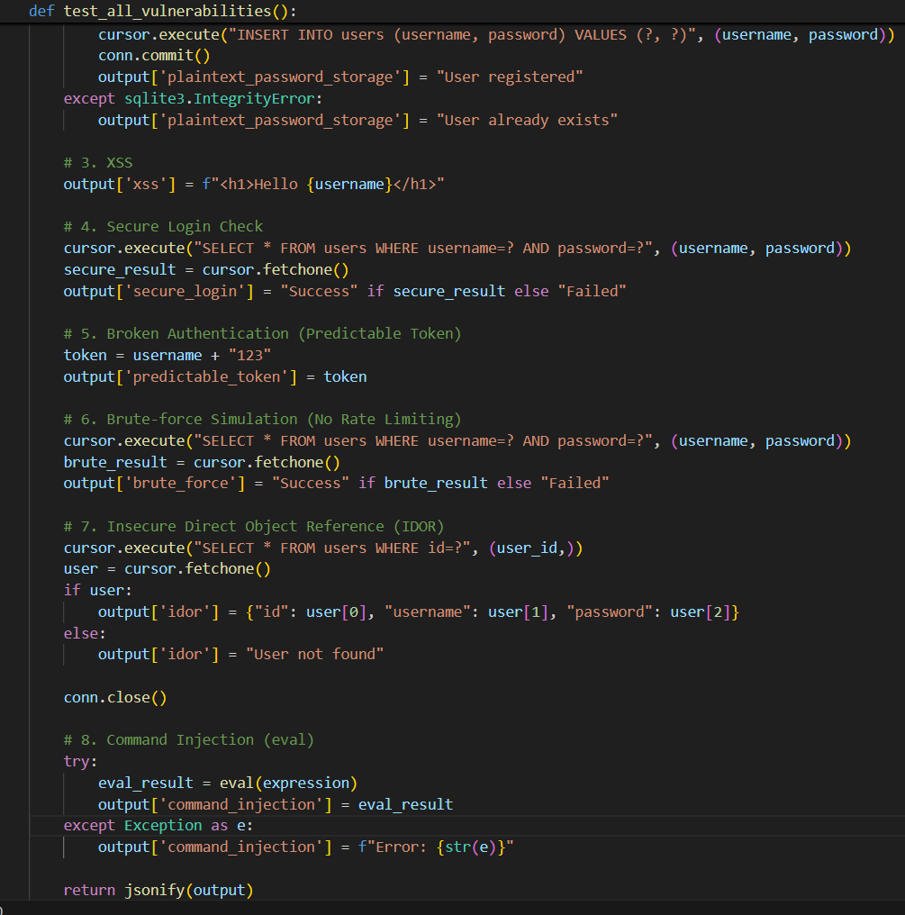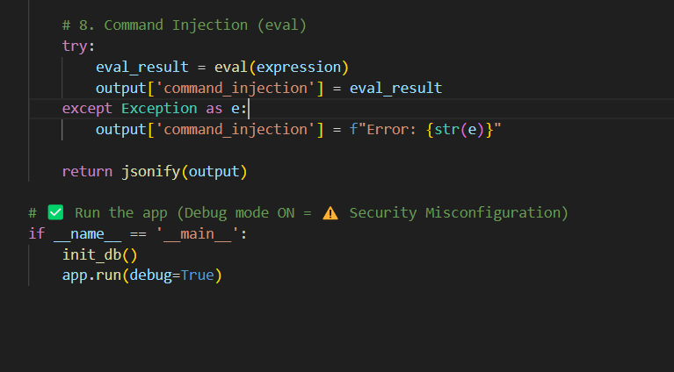

JSON Test Payloads:
- SQL Injection: User inputs are directly concatenated into SQL queries without sanitization, allowing attackers to manipulate the query.
{
"username": "admin' OR '1'='1",
"password": "anything"
}
- Impact: Bypasses authentication, potentially exposing sensitive data.

- Plaintext Password: Passwords are stored in the database without encryption or hashing.
{
"username": "test_user",
"password": "mysecret"
}
- Impact: If the database is compromised, all user passwords are exposed in plaintext.​

- Cross-Site Scripting (XSS): User inputs are rendered in HTML without proper escaping, allowing script injection.
{
"username": "<script>alert('XSS')</script>",
"password": "xss"
}
- Impact: Can lead to session hijacking, defacement, or redirection to malicious sites.​

- Weak Authentication: Authentication relies on matching plaintext credentials without additional security measures.
{
"username": "test_user",
"password": "test123"
}
- Impact: Susceptible to credential stuffing and lacks multi-factor authentication.​

- Predictable Token: Tokens are generated using predictable patterns, such as appending '123' to the username.
{
"username": "john",
"password": "john123"
}
- Impact: Attackers can guess tokens and gain unauthorized access.​

- Brute Force Simulation: No rate limiting or account lockout mechanisms are implemented.
{
"username": "admin",
"password": "wrongpassword"
}
- Impact: Allows attackers to attempt unlimited password guesses.

- IDOR: Access to user data is granted based on user ID without proper authorization checks.
{
"username": "john",
"password": "john123",
"user_id": 1
}
- Impact: Attackers can access or modify data of other users by manipulating user IDs.​

- Command Injection: User inputs are evaluated as code using eval(), allowing execution of arbitrary commands.
{
"username": "test",
"password": "test",
"expression": "__import__('os').system('dir' if os.name == 'nt' else 'ls')"
}
- Impact: Attackers can execute system commands, leading to full system compromise.​

I GAVE 2 EXAMPLE PAYLOADS PENTESTING:
VERIFICATION:
- SQL Injection
- Plaintext Password

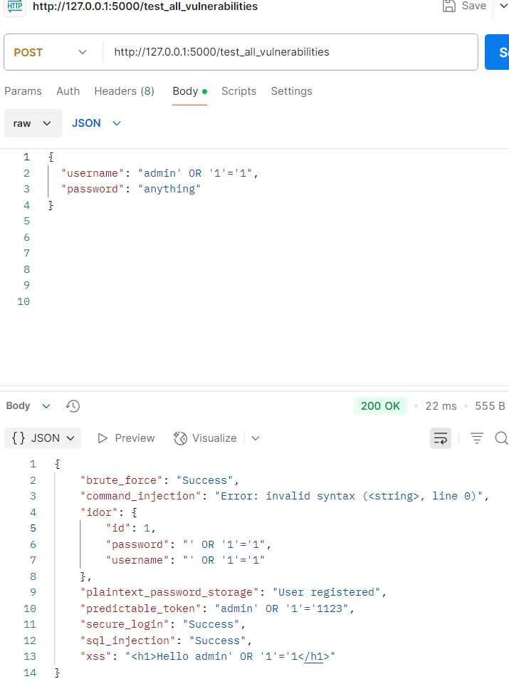
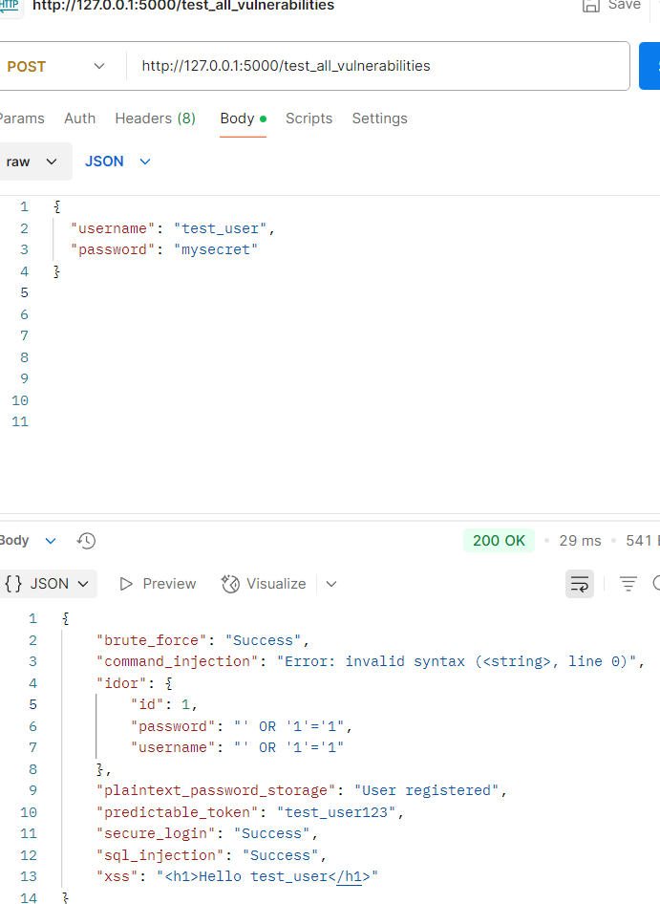

POST Usage Instructions:
- Use POST request to /test_all_vulnerabilities with any of the above payloads using tools like Postman or curl.
- Use POST request to /execute for command injection testing.
/test_all_vulnerabilities — for testing all flaws.
/execute —Specifically for command execution. This is where the eval() vulnerability was demonstrated and later fixed.

Penetration Testing Results:
Each vulnerability was confirmed:
- SQL Injection bypassed login successfully.
- XSS alert box triggered.
- Token was predictable (username123).
- Command Injection executed arbitrary commands.
- IDOR exposed user info from unauthorized ID.
- Brute-force allowed unlimited attempts without lockout.

Specific Vulnerability Focus: Command Injection:
ALLOWED_COMMANDS = { "time": ..., "whoami": ..., "date": ... }
- Only predefined safe commands are allowed.
- eval is removed.
- Prevents arbitrary command execution.

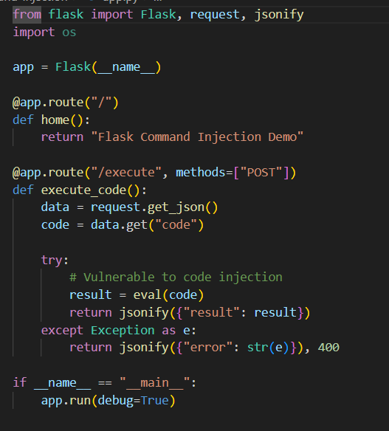
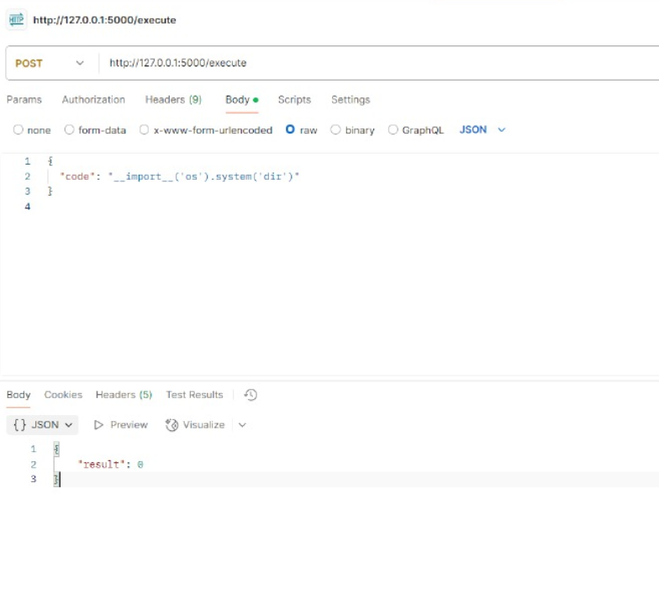

Example Attack Payloads:
- { "code": "5 * 3" }
- { "code": "__import__('os').system('ls')" }
- { "code": "__import__('subprocess').getoutput('whoami')" }

Fixed Code for Command Injection:
You can see here a comparison of malicious payloads versus safe implementation.
- Eval with user input → Dangerous.
- Restricted functions → Safe.”

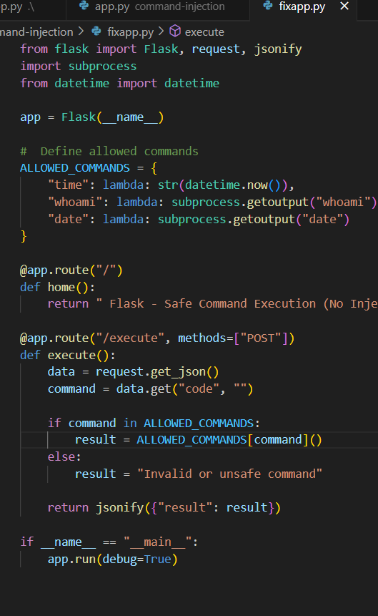
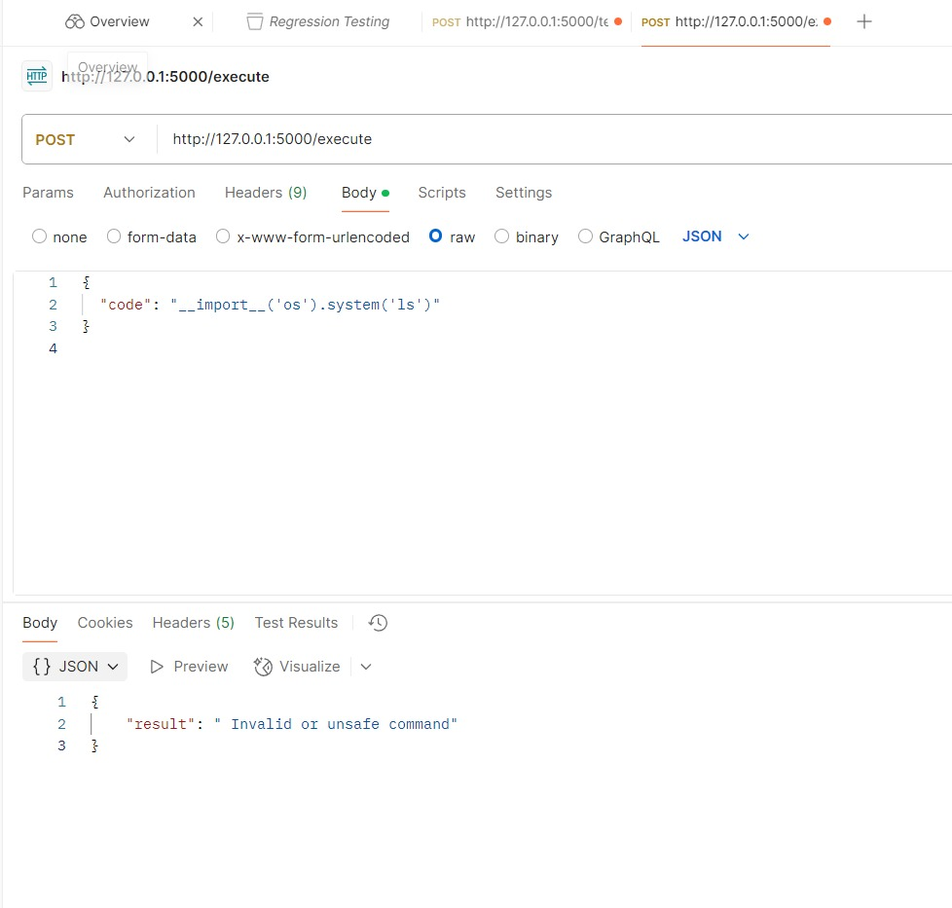

Safe Payload Example:
- { "code": "whoami" }

Conclusion
This project simulated real-world API vulnerabilities to provide practical insights into penetration testing. The most dangerous vulnerability, Command Injection, was studied in detail and mitigated using a secure implementation. This project helps learners understand the importance of input validation, secure coding, and proactive defense.

